Video Club
Used to control the display of content in the client interface videoclub - Adding/removing/editing of content (movies, clips, cartoons, tv-series etc…), .

Fields description
- id - Contents ID in MySQl's database. Is assigned automatically in ascending order fill the database.
- Folder - While adding new content via Admin-interface, folder creates automaticly on storage, in /media/storage/. Name is generated from field “Title” with automatic change to translit;
- Title - Title/Name of content. Appears in the list on the client device;
- Original title - Copyright / Original title of content;
- Restriction - Restriction by age. Appears status: 1 - on, 0 - off. If activated, on client device you will need to enter password to see this content. Password by default - 0000. Password can be changed on clients device in “Settings” ⇒ “Parents control;
- Volume correction - Is used to manually correct volume ;
- Duration, min - Duration of content. Appears on clients interface in contents info;
- Series - Amount of series;
- Claims about audio/video - ;
- edit, send, del, on/off - ;
- Turn on date - .

Content adding
- In admin-interface select “Video club”, select “Add”, fill all the necessary fields. Folder on storage will be created automaticly, if storage and Stalker MW are configured right;
- Upload content on storage server in created folder, after that in admin-interface after pressing on corresponding title on content the additional information will be available(Server,Folder,Series). If content is present on storage and available, then title will display in green.
<spoiler|Edit page> 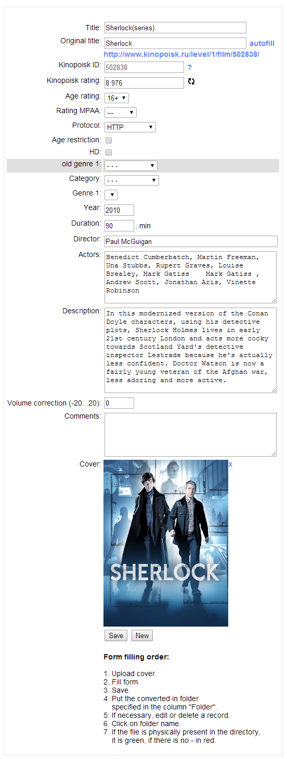 </spoiler>
<spoiler|Additional Information> 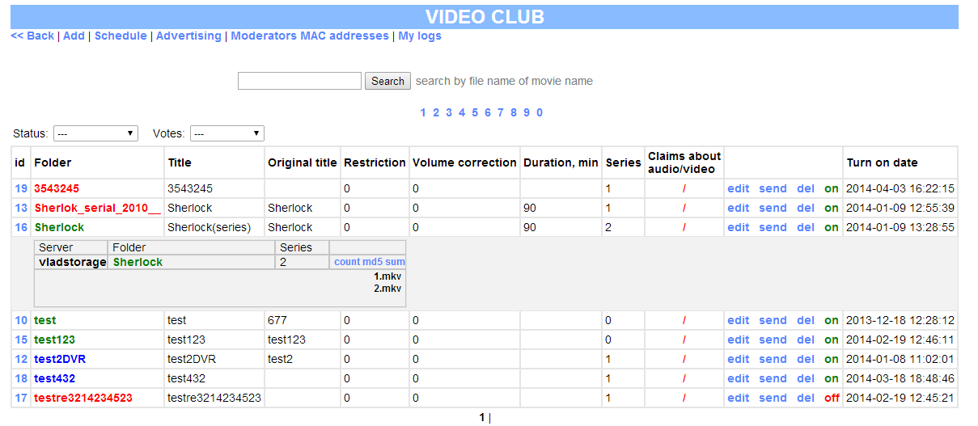 </spoiler>

