Firmware update on STB MAG260
Actual firmware for STB MAG260 could be download here:
STB MAG260 A20
STB MAG260 A10

Updating from Settings
- 1. Open “Settings”
- 2. Open “About set-top box”
- 3. Open “System update”
- 4. Open “View updates”
- 5. Choose necessary firmware and press “Download”
- 6. After downloading there will “Accept” message. If there is no need in updating (or some another reason) then you must press “Cancel” duting 10 seconds. Otherwise it will be automatically updated.

Updating from USB device
- 1. Open Recovery mode
- 2. Choose necessary variant of updating depending on which USB port used:
In case if front port is used:
- apply update from USB storage connected to front
In case if back port is used:
- apply update from USB storage connected to back
- 3. Choose file and wait for autoupdate.

Firmware updating using SD card
- 1. Download and unzip .zip archive.
- 2. Connect MicroSD to PC and record image using HDDRawCopy utility.
Work with HDDRawCopy
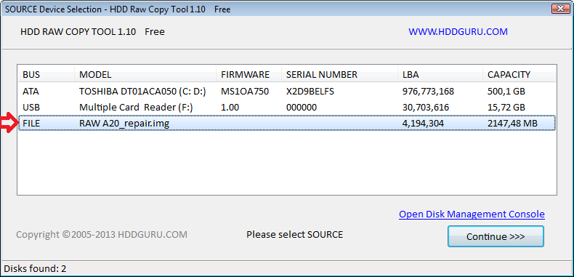
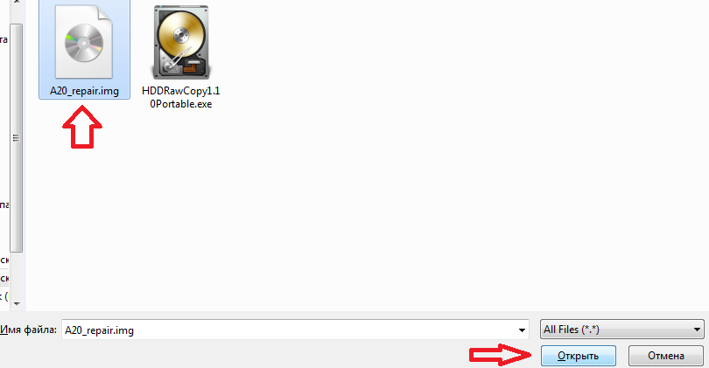
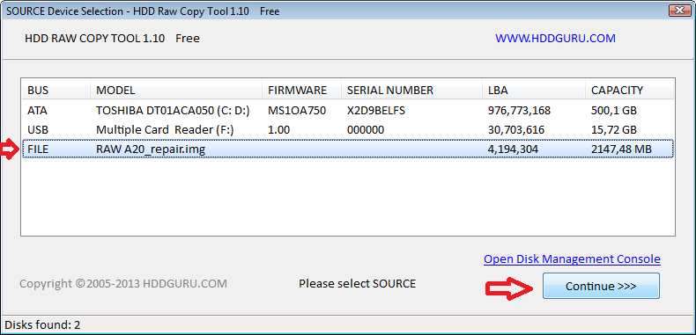
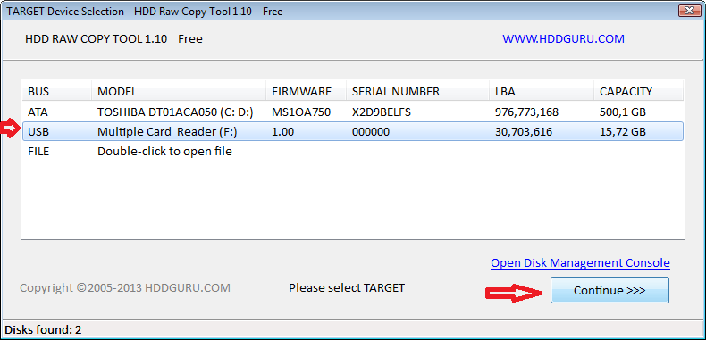
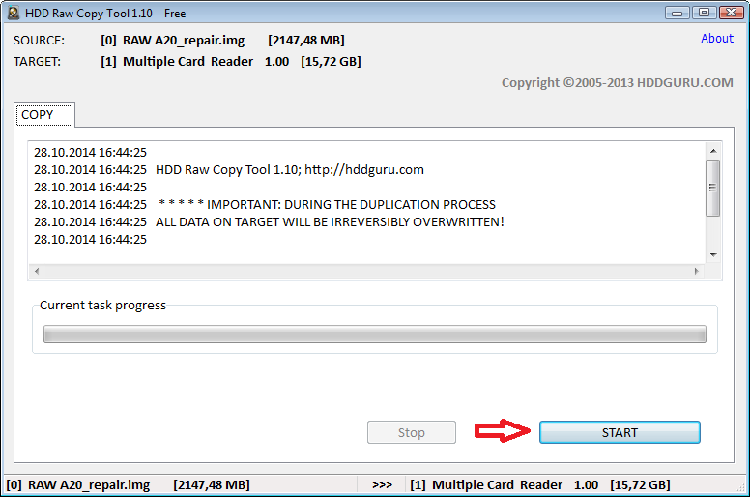
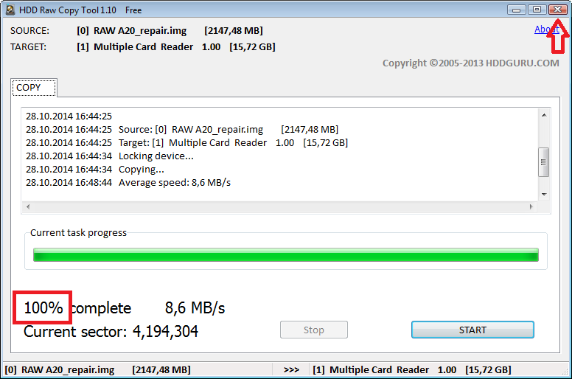
- 3. Turn off STB and connect SD card to port on the back side of STB.
MicroSD port on the back side
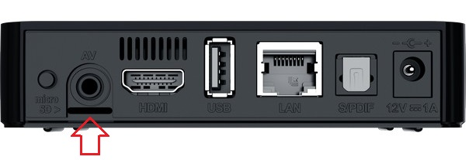
- 4. Turn on STB and wait for updating.
Take into account that updating proceed on background and do not display. STB will turned off after updating is complete - in this way you can determine that updating is complete.
- 5. Remve SD card and turn on STB.

