Portals page and embedded portal ("SET/SETUP") disabling while loading
If the values portal1 and portal2 have been setup, then there is opportunity to choose them while loading:
<spoiler|Pic.1>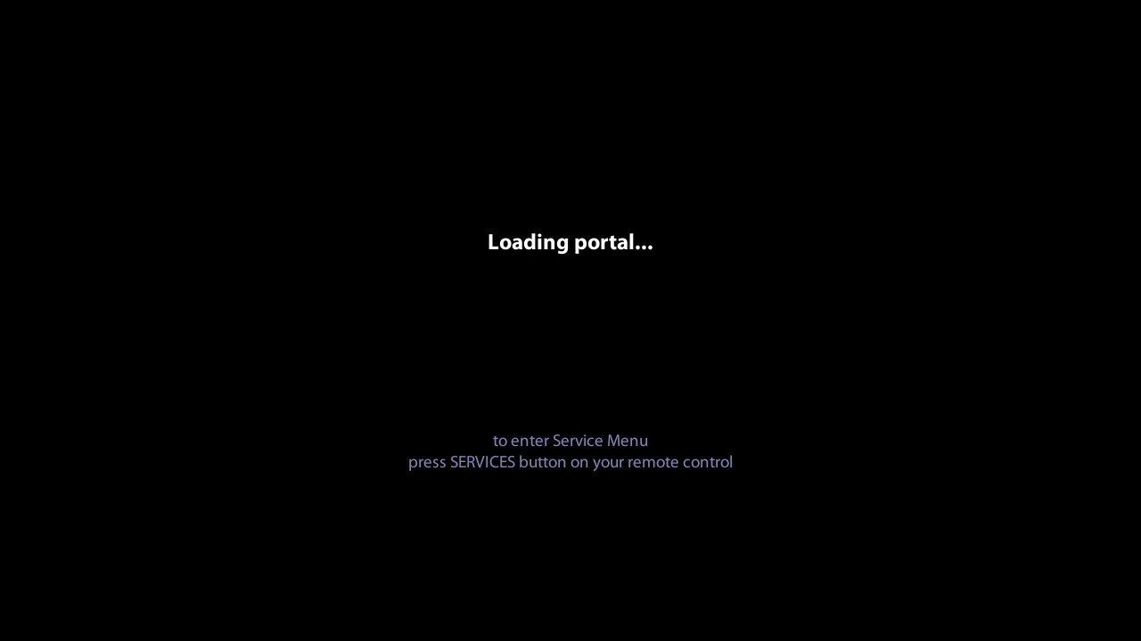</spoiler> <spoiler|Pic.2>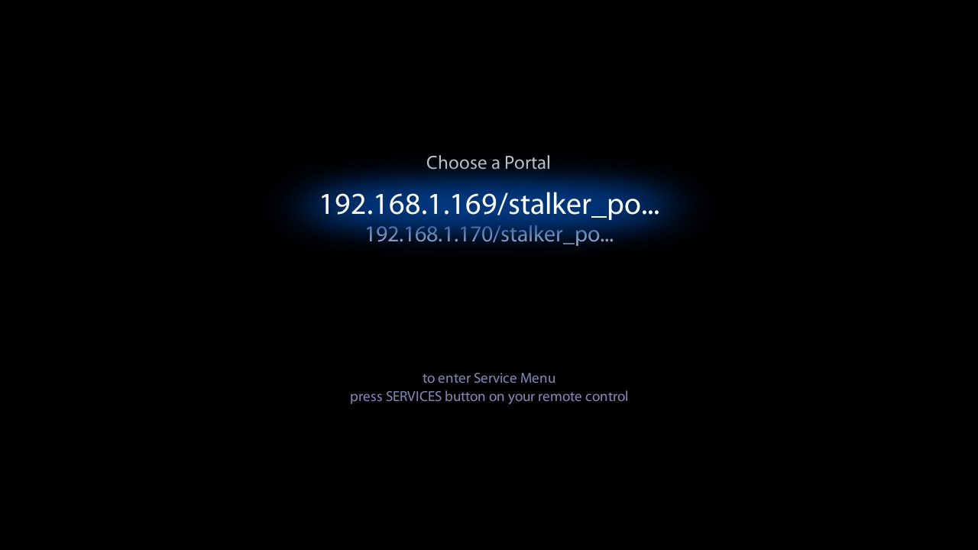</spoiler>
Edit file: /home/web/index.html:
- String 84 - There is black screen while loading, but there is opportunity to open embedded portal by pressing SET/SETUP .
var BLACK_SCREEN_WHILE_LOADING = 0;
change to:
var BLACK_SCREEN_WHILE_LOADING = 1;
- String 464 - disabling opportunity to open embedded portal by pressing SET/SETUP
case 120: // "Services"
if(!servicePressed){
infoButtonPressed();
}
break;
}
change to:
case 120: // "Services"
if(!servicePressed){
if(!BLACK_SCREEN_WHILE_LOADING){
infoButtonPressed();
}
}
break;
}
- String 464 - Opening “System settings” by pressing SET/SETUP button instead of embedded portal openning.
case 120: // "Services"
if(!servicePressed){
infoButtonPressed();
}
break;
}
Change to:
case 120: // "Services"
if(!servicePressed){
gSTB.StartLocalCfg();
}
break;
}
<spoiler|Example of edit file index.html>
<!DOCTYPE HTML PUBLIC "-//W3C//DTD HTML 4.01 Transitional//EN"
"http://www.w3.org/TR/html4/loose.dtd">
<html>
<head>
<meta http-equiv="Content-Type" content="text/html; charset=UTF-8">
<link rel="stylesheet" type="text/css" title="CSS Stylesheet" href="style.css">
<title></title>
<script language="JavaScript" src="var_index.js"></script>
<script language="JavaScript" src="loader.js" defer="true"></script>
<style type="text/css">
body {margin:0px}
.ArialBold18{
font-family: "Myriad Pro";
font-size:25px;
font-weight:bold;
text-align:center;
color:#FFF;
}
.Verdana14Grey{
font-family: "Myriad Pro";
font-size:19px;
font-weight:normal;
text-align:center;
color:#888;
text-shadow:#0000FF 0 0 20px;
}
#portalsMenu{
position:relative;
top:0px;
width:620px;
height:150px;
margin:auto;
text-align: center;
display:none;
}
#title{
position:relative;
top:0px;
left:0px;
width:620px;
height:50px;
text-align: center;
font-family: "Myriad Pro";
font-size:25px;
font-weight:normal;
text-align:center;
color:#CCC;
}
.menu_table{
position:relative;
top:0px;
width:620px;
height:150px;
margin:auto;
text-align: center;
}
.menu_normal{
height:40px;
font-family:"Myriad Pro";
font-size:30px;
color:#a7b7d6;
}
.fadeBg{
position:absolute;
left:0px;
width:620px;
height:150px;
font-family:"Myriad Pro";
font-size:40px;
color:#FFFFFF;
text-align:center;
line-height: 150px;
margin-top: 0px;
background: url(img/fade_bg.png) no-repeat;
z-index:1;
visibility:hidden;
}
#menu0 {top: -5px}
#menu1 {top: 35px}
</style>
<script>
var BLACK_SCREEN_WHILE_LOADING = 0; // opening portal - black screen without messages
var rowsTotal = 0, portal_1, portal_2, curPageId, timerRedirect, timerDhcpPortal, timerToMenu, repeatTimer,
noPortalsURL, servicePressed = false;
var curMenuIdx = null,
repeatTimeout = false, // it is necessary to reset timer for portals opening
LOADING = '',
PORTAL_LOADING = '',
SERVICE_LOADING = '',
DHCP_PORTAL_LOADING = '',
sm_DirectionMsg = '',
sm_Message = '',
SERVICE_PRESS_INTERVAL = 10000,
CONTINUE = true,
patIP = /[\n\w\S\s]*PORTAL_IP="(\S+)*"[\n\w\S\s]*/,
patPortal1 = /[\n\w\S\s]*PORTAL_1="(\S+)*"[\n\w\S\s]*/,
patPortal2 = /[\n\w\S\s]*PORTAL_2="(\S+)*"[\n\w\S\s]*/;
var PORTAL_NAME_MAX_LENGTH = 24,
CUT_STRING_SYMBOL = '...';
function init(){
if (!STB_EMULATION) {
initXpcom();
}
try{
stb.InitPlayer();
}catch(e){
}
//alert(document.location.search);
window.resizeTo(720, 576);
x=(screen.width - 720)/2
y=(screen.height - 576)/2
window.moveTo(x, y);
if(/nms/i.test(window.location.search)){
_debug('NMS version');
BLACK_SCREEN_WHILE_LOADING = 1;
}
_debug('************* INDEX.html : STB STARTED HERE ******************');
curLangIdx = getCurrentLanguage();
// _debug('curLang = '+getCurrentLanguage());
stb.EnableServiceButton(false);
loadScript ('lang/'+curLangIdx+'/resource.js', 'fillPage()');
failTimer = setTimeout(languageResourcesFailed, NO_LANGUAGE_TIMEOUT);
}
/*function ifNoLanguage(){ //function of language setting if there is wrong values
setEnvironmentValue('language','en');
setTimeout(curLangIdx = getCurrentLanguage(),2000)
_debug('curLang = '+getCurrentLanguage());
loadScript ('lang/'+curLangIdx+'/resource.js', 'fillPage()');
}
*/
function fillPage(){
if (!checkLanguageResourceFile()) {
return;
}
if (!BLACK_SCREEN_WHILE_LOADING){
LOADING = '<span class="ArialBold18">' + pmenu_Loading + '</span>';
PORTAL_LOADING = '<span class="ArialBold18">' + pmenu_PortalLoading + '</span>';
DHCP_PORTAL_LOADING = '<span class="ArialBold18">' + pmenu_DhcpPortalLoading + '</span>';
SERVICE_LOADING = '<span class="ArialBold18">' + pmenu_ServiceMenuLoading + '</span>';
//document.body.style.background = 'url(new_menu/img/576/bg.jpg) no-repeat';
_debug("background SETUP!")
}
// Delaying main init() for background
setTimeout(init1,200);
}
function init1(){
var a = check_portals();
switch (a) {
case 0:
noPortalsURL = "services.html"; // open service menu by default
sm_DirectionMsg = SERVICE_LOADING;
sm_Message = '';
var time = 1;
var use_portal_dhcp = getEnvironmentValue('use_portal_dhcp').toString();
if (use_portal_dhcp == "true"){
var portal_dhcp = readFromStb_URL ('portal_dhcp', '');
if (portal_dhcp){
// переходим на портал DHCP
noPortalsURL = portal_dhcp;
sm_DirectionMsg = DHCP_PORTAL_LOADING;
sm_Message = pmenu_PressServiceButton;
time = SERVICE_PRESS_INTERVAL;
}
}
if (BLACK_SCREEN_WHILE_LOADING){
document.location = noPortalsURL;
return;
}
else{
document.getElementById('menu_container').innerHTML = sm_DirectionMsg;
document.getElementById('gotoServ').innerHTML = sm_Message;
timerDhcpPortal = setTimeout(redirectNoPortals,time);
}
break;
case 1:
var time = 1;
var use_portal_dhcp = getEnvironmentValue('use_portal_dhcp').toString();
if (use_portal_dhcp == "true" && !(/nms/i.test(window.location.search))){
var portal_dhcp = readFromStb_URL ('portal_dhcp', '');
if (portal_dhcp ){
// переходим на портал DHCP
noPortalsURL = portal_dhcp;
sm_DirectionMsg = DHCP_PORTAL_LOADING;
sm_Message = pmenu_PressServiceButton;
time = SERVICE_PRESS_INTERVAL;
_debug(noPortalsURL);
document.location = noPortalsURL;
timerDhcpPortal = setTimeout(redirectNoPortals,time);
}
}
// one portal - open it in 3 seconds
if (BLACK_SCREEN_WHILE_LOADING){
// no messages on the screen, no background image, page div is display = none
document.getElementById("pageIndex").style.display = 'none';
}
else{
// send message to the screen, background should be loaded
document.getElementById("menu_container").innerHTML = PORTAL_LOADING;
document.getElementById('gotoServ').innerHTML = pmenu_PressServiceButton;
}
timerRedirect = setTimeout(redirect,SERVICE_PRESS_INTERVAL);
break;
case 2:
var time = 1;
var use_portal_dhcp = getEnvironmentValue('use_portal_dhcp').toString();
if (use_portal_dhcp == "true" && !(/nms/i.test(window.location.search))){
var portal_dhcp = readFromStb_URL ('portal_dhcp', '');
if (portal_dhcp){
// open DHCP portal
noPortalsURL = portal_dhcp;
sm_DirectionMsg = DHCP_PORTAL_LOADING;
sm_Message = pmenu_PressServiceButton;
time = SERVICE_PRESS_INTERVAL;
_debug(noPortalsURL);
document.location = noPortalsURL;
timerDhcpPortal = setTimeout(redirectNoPortals,time);
}
}
// both portals are presented - open portals menu
if (BLACK_SCREEN_WHILE_LOADING){
// background was disabled - turning on it
//document.body.style.background = 'url(img/main.png) no-repeat';
setTimeout (continue_TwoPortals,1);
return;
}
else{
document.getElementById('menu_container').innerHTML = LOADING;
sm_Message = pmenu_PressServiceButton;
timerToMenu = setTimeout(init_continue,1);
}
break;
}
rowsTotal = a;
curMenuIdx = 0;
}
function redirectNoPortals(){
document.location = noPortalsURL;
}
function continue_TwoPortals(){
rowsTotal = 2;
curMenuIdx = 0;
sm_Message = pmenu_PressServiceButton;
timerToMenu = setTimeout(init_continue,1);
}
function init_continue(){
document.getElementById('gotoServ').innerHTML = sm_Message;
if (servicePressed) {
document.location = "services.html";
return;
}
try{
stb.SetVideoState(0);
}catch(e){
_debug(e)
}
show_menu();
}
// Function is checking portal records in CFG and returning their quantity beginning from 0
function check_portals(){
var ret = 0;
if (portal_1 = getPortalName('portal1')) // getPortalName("Portal1")
ret++;
if (portal_2 = getPortalName('portal2')) // getPortalName("Portal2")
ret++;
return ret;
}
function beforeLoadingPortal(msg){
if (BLACK_SCREEN_WHILE_LOADING){
document.body.style.background = 'none';
document.getElementById("pageIndex").style.display = 'none';
}
else{
document.getElementById("menu_container").innerHTML = msg;
document.getElementById("gotoServ").innerHTML = "";
}
}
// There is portal_1 or portal_2
function redirect(){
var p, url;
beforeLoadingPortal(PORTAL_LOADING);
if(!portal_1){
portal_1 = portal_2;
}
p = getProtoAndHostname(portal_1);
if (p.protocol) {
url = portal_1;
}
else{
url = 'http://' + portal_1;
}
location.href = url;
}
function show_menu(){
var b = '';
b += '<div id="portalsMenu">';
b += '<div id="title"></div>';
b += '<div class="menu_table">';
b += '<div class="menu_normal" id="td0"></div>';
b += '<div class="menu_normal" id="td1"></div>';
b += '</div>';
b += '<div class="fadeBg" id="menu0"></div>';
b += '<div class="fadeBg" id="menu1"></div>';
b += '</div>';
//
document.getElementById('menu_container').innerHTML = b;
document.getElementById('title').innerHTML = pmenu_PortalChoice;
document.getElementById('td0').innerHTML = cutString(portal_1,PORTAL_NAME_MAX_LENGTH);
document.getElementById('td1').innerHTML = cutString(portal_2,PORTAL_NAME_MAX_LENGTH);
document.getElementById('menu0').innerHTML = cutString(portal_1,PORTAL_NAME_MAX_LENGTH);
document.getElementById('menu1').innerHTML = cutString(portal_2,PORTAL_NAME_MAX_LENGTH);
document.getElementById("portalsMenu").style.display = "block";
menuItem_Select(curMenuIdx);
}
function cutString(str,len){
var a = str;
if (a.length > len){
a = str.substr(0,len);
a += CUT_STRING_SYMBOL;
}
return a;
}
function menuItem_Select(idx){
if (idx != null) {
document.getElementById("td"+idx).style.visibility = "hidden";
document.getElementById("menu"+idx).style.visibility = "visible";
}
}
function menuItem_Unselect(idx){
if (idx != null) {
document.getElementById("td"+idx).style.visibility = "visible";
document.getElementById("menu"+idx).style.visibility = "hidden";
}
}
function getkeydown(e) {
_debug('getkeydown() keyCode:'+e.keyCode+'; which:'+e.which+ ' alt: '+ e.altKey+ ' ctrlKey: '+e.ctrlKey);
ec = e.keyCode;
ew = e.which;
es = e.shiftKey;
pat = /^(\S+)_(\S+)/;
// NOTE!!! This code is necessary to distinguish the codes, which are generating by RC
// Accept the agreement:
// Ctrl = 1, Alt = 0, keyCode = 32 (Space) : ENTER on the keyboard and OK on the RC
// Ctrl = 0, Alt = 1, keyCode = 32 (Space) : SPACE on the keyboard and MIC on the RC
if (ec == 32 && e.ctrlKey && !e.altKey) {
ec = 13;
ew = 13;
}
if (CHECK_ALT_CTRL) {
altCtrl = e.altKey ;//&& e.ctrlKey;
}
else{
altCtrl = 1;
}
/*if(altCtrl){
ec = 0;
}
else {
if(e.ctrlKey){
ew=0;
}
else{
if(ec > 90 && ew != 0){
ec = 0;
}
}
}*/
if (altCtrl && ew == 117) { // "Power" button
if (!inStandBy) { // Switching off
if (timerRedirect){
clearTimeout(timerRedirect);
timerRedirect = null;
repeatTimer = 'Redirect';
repeatTimeout = true;
}
if (timerToMenu){
clearTimeout(timerToMenu);
timerToMenu = null;
repeatTimer = 'ToMenu';
repeatTimeout = true;
}
}
else{ // Switching on
if (repeatTimeout){
switch (repeatTimer){
case 'Redirect':
timerRedirect = setTimeout(redirect, SERVICE_PRESS_INTERVAL);
break;
case 'ToMenu':
timerToMenu = setTimeout(init_continue, SERVICE_PRESS_INTERVAL);
break;
}
repeatTimeout = false;
repeatTimer = null;
}
}
inStandBy = !inStandBy;
if (!STB_EMULATION){
stb_OnOff(inStandBy);
stb.StandBy(inStandBy);
}
return;
}
if (inStandBy) {
CONTINUE = false;
return;
}
switch (ec){
case 38: // Up
{
if (curMenuIdx) {
menuItem_Unselect(curMenuIdx);
curMenuIdx--;
menuItem_Select(curMenuIdx);
}
break;
}
case 40: // Down
{
if (curMenuIdx < rowsTotal-1) {
menuItem_Unselect(curMenuIdx);
curMenuIdx++;
menuItem_Select(curMenuIdx);
}
break;
}
case 13: // OK
gotoPage(curMenuIdx);
break;
case 120: // "Services"
if(!servicePressed){
infoButtonPressed();
}
break;
}
if (CFG_PARAM_DEBUG) {
switch (ew) {
case 113: // Debug "Info" by "Q". This code doesn't work with RC
infoButtonPressed();
break;
}
}
}
function infoButtonPressed(){
if (timerRedirect){
clearTimeout(timerRedirect);
timerRedirect = null;
}
if (timerToMenu){
clearTimeout(timerToMenu);
timerToMenu = null;
}
//document.getElementById("menu_container").innerHTML = SERVICE_LOADING; document.getElementById("gotoServ").innerHTML = "";
beforeLoadingPortal(SERVICE_LOADING);
sm_Message = '';
servicePressed = true;
_debug('servicePressed = '+servicePressed);
setTimeout(init_continue,100);
}
// menuIdx = index from 0 in menu
function gotoPage(menuIdx){
beforeLoadingPortal(PORTAL_LOADING);
var url = eval("portal_"+(menuIdx+1));
var p = getProtoAndHostname(url);
if (!p.protocol) {
url = 'http://' + url;
}
//document.location = 'http://'+serv_ip+'/'+portal+'/index.html';
_debug("HERE !!!! > "+url);
location.href = url;
}
</script>
</head>
<body onload="loader()" onKeyPress="getkeydown(event)">
<div id="pageIndex">
<table align="center" width="630" height="420" style="table-layout:fixed;">
<tr align="center" valign="middle">
<td height="400" id="menu_container"></td>
</tr>
<tr>
<td height="*"></td>
</tr>
<tr>
<td id="gotoServ" class="Verdana14Grey" height="50" align="center"></td>
</tr>
</table>
</div>
<!-- Modal window -->
<div id="pad" align="center"></div>
<div id="msgWindow" align="center"></div>
<!-- /Modal window -->
<div id="xpcom" style="margin:2px;"></div>
<div id="emul"></div>
</body>
</html>
</spoiler>

