The pin connector is shown in the picture:
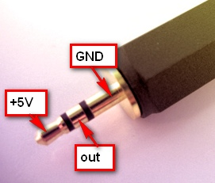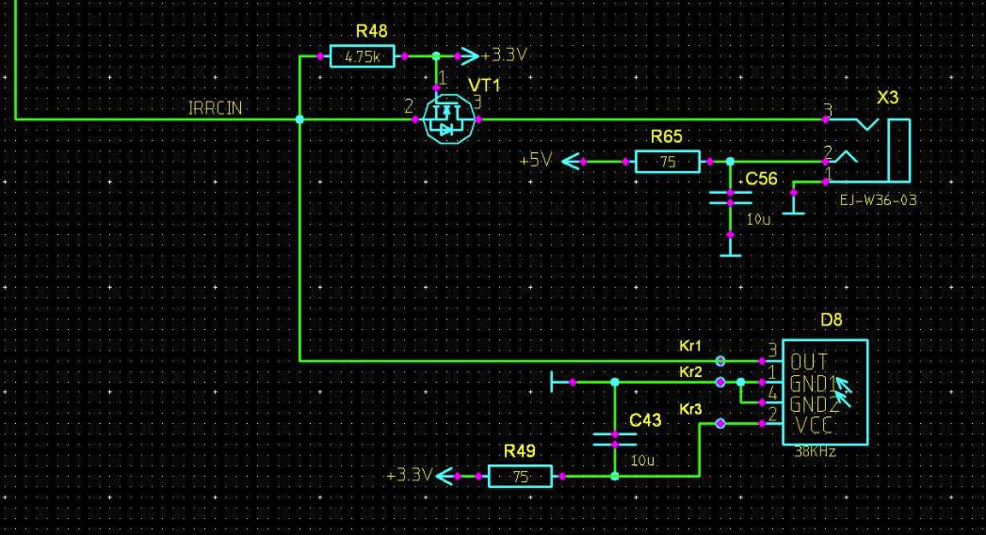
- tip - power +5V;
- ring - signal;
- base - ground;
- Connector - 2.5 mm stereo jack.
As a photodetector you can use any integrated receiver for 38KHz with 5V power supply.
For example:
TSOP31438 http://www.vishay.com/docs/82492/tsop312.pdf
TSOP58438 http://www.vishay.com/docs/82461/tsop582.pdf
With high probability the receiver can be the same as computer TV tuner - they quite often have the same type of connector and pinout.
It is recommended to install capacitor 1-10mcF near receiver for improving power supplies immunity.

