Language, Time & Date, Location & Weather

Interface language
In internal software of MAG200/250
- Go to “System settings” by pressing «Setup», «Services» or «SET» on the remote control (depending on the version the remote control)
- “Advanced settings”
- “Language” - select the language by pressing the left or right on the remote control
- Confirm selection by pressing the “OK” button at the bottom of the Settings window
- To correctly apply the localization the restart is required!!!

Time and Date
STB MAG-200/250 used for time synchronization protocol NTP
If your network does not use the NTP-server, you can use the shared external NTP-servers. To work correctly with an external NTP, you must have an Internet connection on the STB.
Servers list:
Europe
North America
Oceania
Asia
Additional information: pool.ntp.org
Information about using of the pool NTP.

To do this in internal software of MAG-200/250
- Enter the “System settings” - by pressing «Setup», «Services» or «SET» on the remote control (depending on the version the remote control)
- Select “Servers”
- In the input field “NTP server” enter the address of the NTP server
- Confirm “OK”
- Enter the “Advanced Settings”
- In the input field “Time zone” enter your time zone
- Confirm “OK”
- “Reboot”
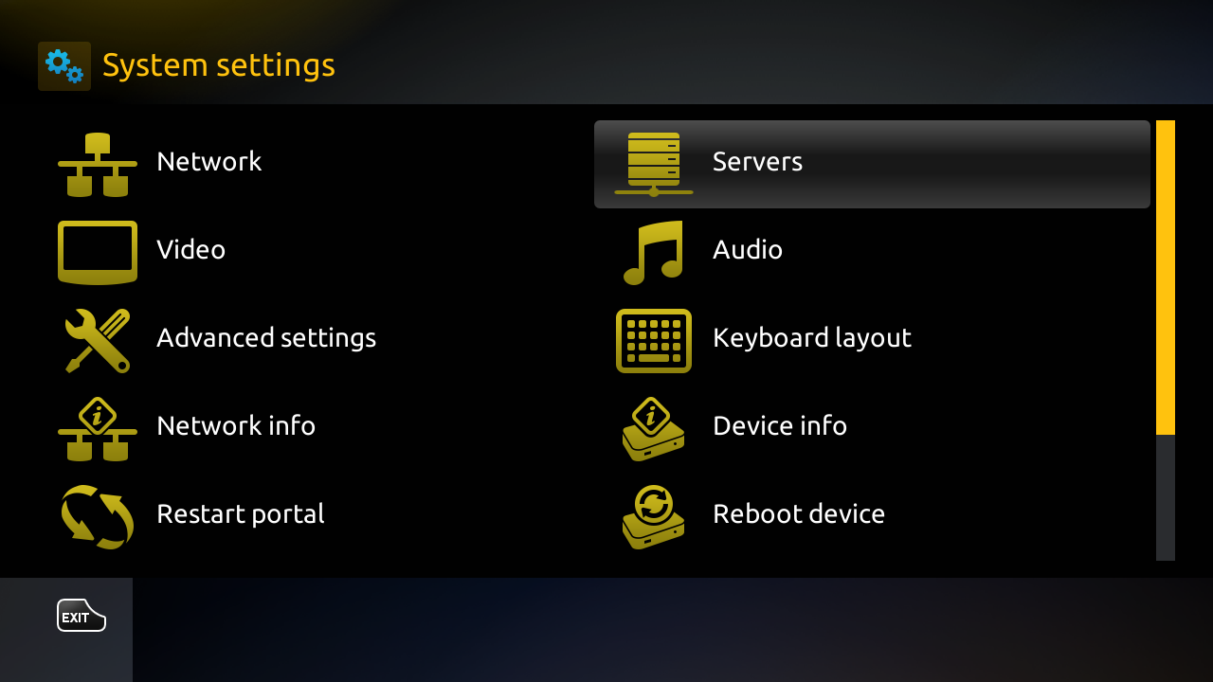1
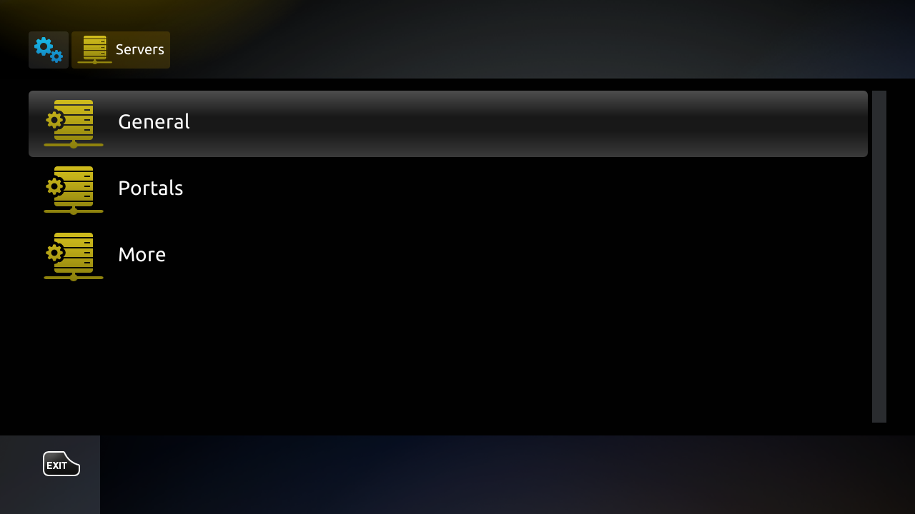2
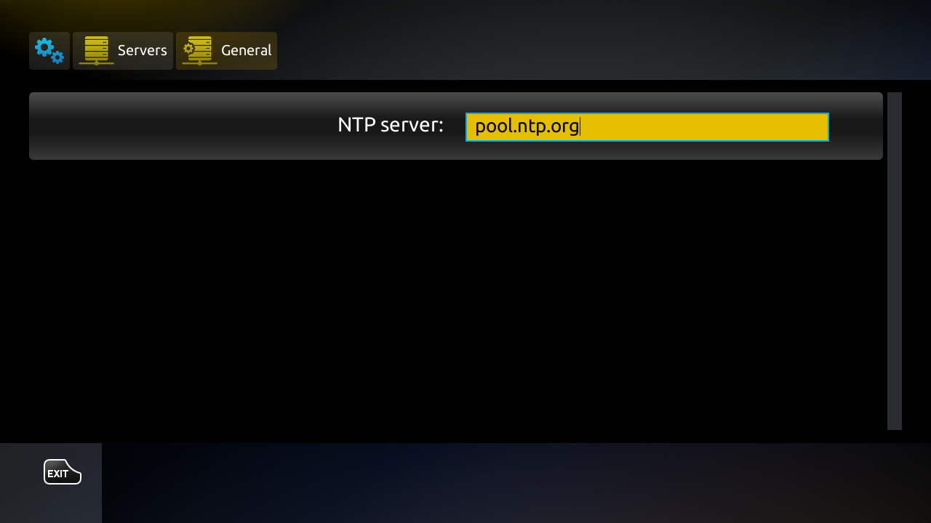3

Location and Weather
- In the main menu of internal software select “Weather”
- Enter the name of the city or locality for which the weather will be displayed.
Using the onscreen keyboard or USB keyboard (Call/hide the onscreen keyboard press the “KB” button on the remote control)
- In the drop-down list select the locality, and press “OK” button on the remote control

