Poedit

Application interface description v 1.0

Introduction
Current document shows aspects of software (Poedit application). This document contains description of environment and principals, which should be realized while localization of project. Also it contains application interface description, main functions and events.

Application installation
First of all it is necessary to download application from official website http://www.poedit.net/download.php After installation open File/Preferences in Menu and enter your name & e-mail. In “Editor” tab remove select from option “Automatically compile .mo file on save”. Press “ОК”.

Description of translation interface of PO files
Application interface contains functions which is necessary as for language file's generation, as for further translations of them to another language. All generated language files have extension *.po (for example ru.po), and could be translated in comfortable form to other languages by group of translators using this application. Those localizations can be integrated fast and easy in project. Next in this instruction is interface description which shows application using by group of translators.
There is described next elements of application on the picture:
- text, which should be translated
- text, which is translated automatically and should be checked. If it is correct, then it is necessary to confirm it, by removing select “Fuzzy” in Menu, or correct it manually
- text, which should be translated
- translation
- comment to initial text (often using when the test is the part of huge sentence)
- text has comment
- text is translated or correct by you and is correct
Example:
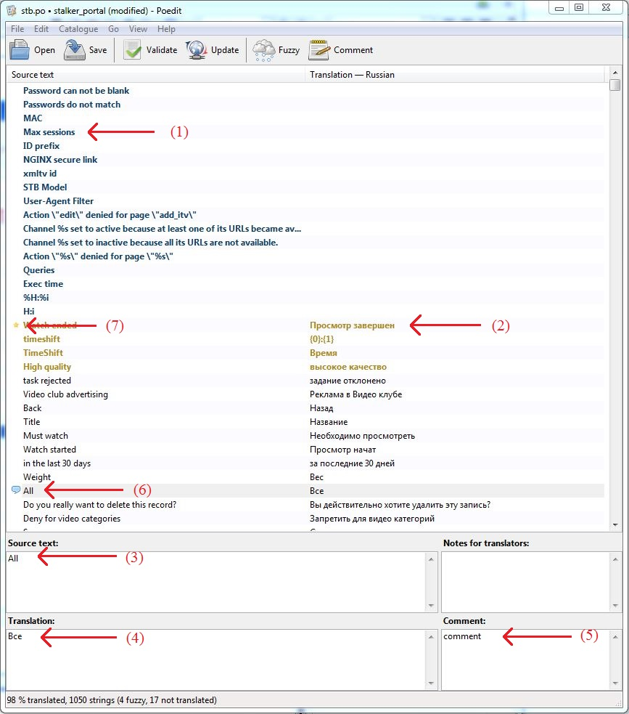

To add new localization:
- 1. Download and untar portal-dev-*.tgz from http://soft.infomir.com.ua/
- 2. Find, copy and edit PO files of localization (they are in folders lang in developer version of portal) with Poedit.
./public/portal/master_settings/lang
./public/portal/lang
./public/app/dlman/lang
./public/app/ibman/lang
./public/app/pvr/lang
./public/app/help/lang
./system/settings/lang
./system/updater/lang
./system/pages/loader/lang
- 3. In /portal/system/tools.js
in function
getCurrentLanguage ( langList )
add in massive new localization
['en', 'ru', 'uk', 'de', 'es', 'bg']
- 4. Run script portal/tools/build.gettext.sh or build.gettext.cmd (for Windows). Before running script you need to run npm install from portal/tools/, nodejs and npm should be installed.
Compiling embedded portal from source codes
- 5. In rootfs in /etc/languages_utf8.txt, add new localization.

If there is need to add localization for virtual keyboard:
- a. Edit files in system/keyboard/js/
- b. /system/keyboard/js/boards.js - language+layout(buttons)
And goto step 4.

