How to configure share folders on PC with MS Windows (SAMBA)

PC
About System:
OS - Windows 7 64-bit
PC name - ZSUP-Vlad
Workgroup - WORKGROUP
Use in PC name and Workgroup field only Latin symbols.

Share access to folder in Windows 7
Folder ForShare
Goto folder Properties > Sharing > Share Select user “Everyone” (If you don't have such user - add it), set Permission level and click on share button.
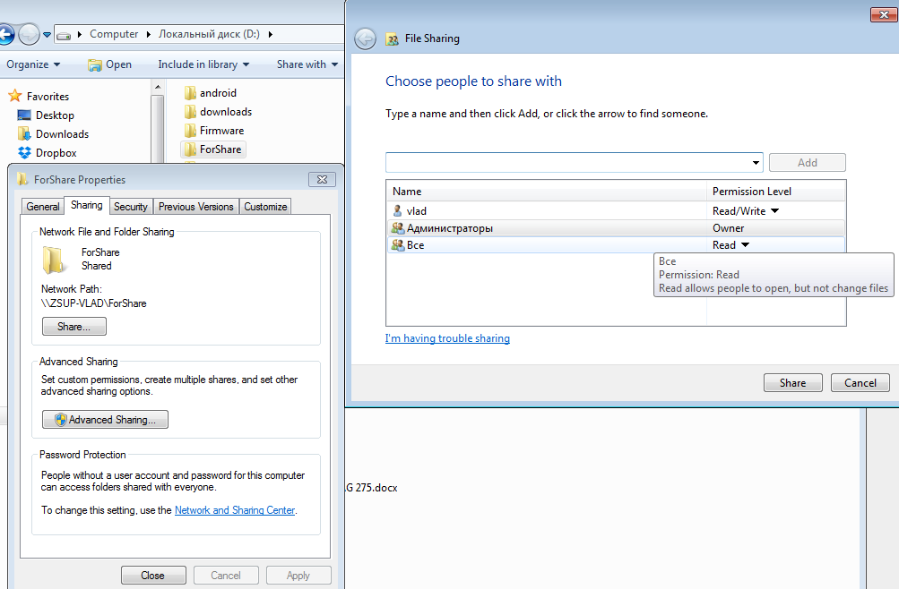2

Network and sharing Center

Advanced sharing settings.

Home or Work
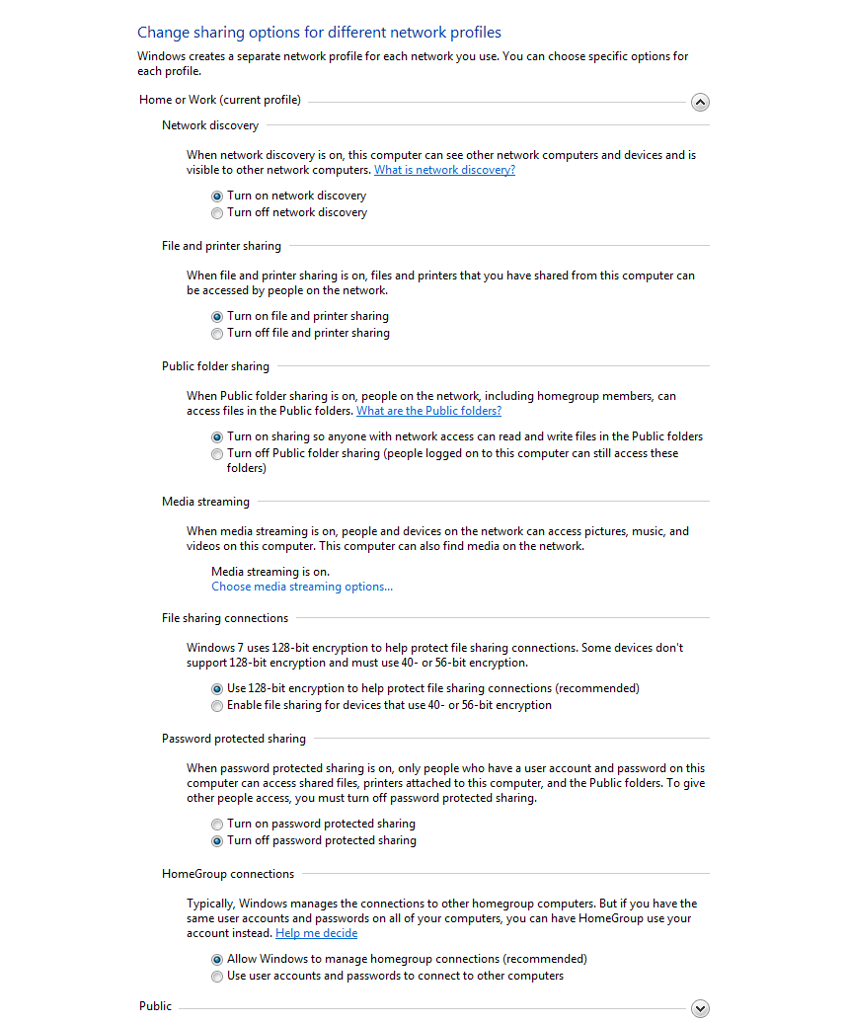Home or Work

Public
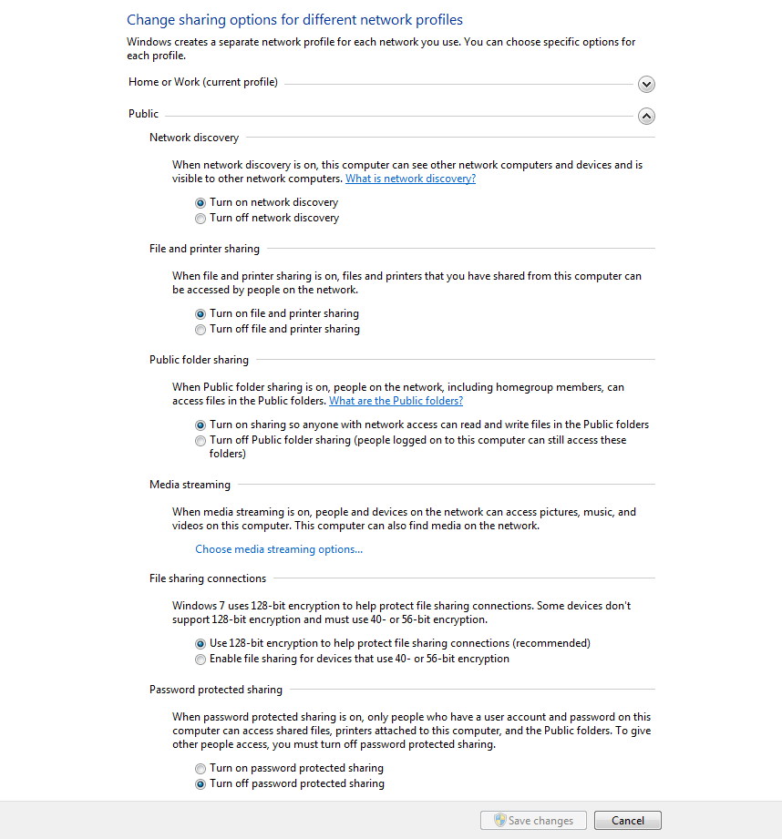Public

STB
Shared folder is accessable on STB.
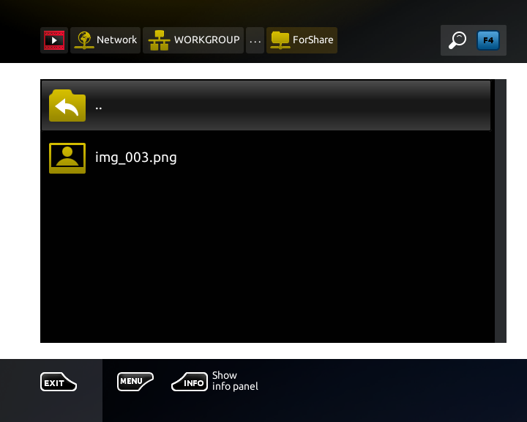3

