MAG256 - Reset to default settings, boot mode change, emergency mode
Press and hold service button (FN) on back side of STB until STB is power off, or during 2 seconds after power on. Switching between modes done by releasing button at specific time according to LED indication.
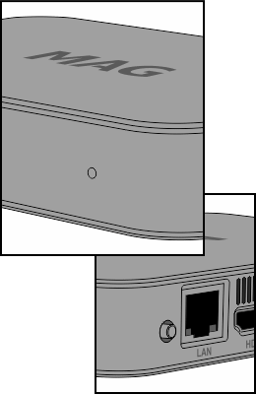
There are 4 modes:
- Mode 1. STB load from first U-boot - Press and hold service button, power on STB. Wait until LED indicator change it's mode (LED is white, slow blinking). If button button will be released STB will load in mode 1. Not releasing of button - STB will go to mode 2.
- Mode 2. Switch to alternative NAND - (White LED, fast blink). If button button will be released STB will load in mode 2. Continue to hold will result in - go to mode 3.
- Mode 3. Reset to default settings - (Red LED, fast blink). If button button will be released STB will load in mode 3. Continue to hold will result in - go to mode 4.
- Mode 4. “Emergency-mode” - STB Boot from USB/DHCP - (Red LED, without blinking). If button button will be released STB will load in mode 4. Continue to hold will result in - Standard load.

"Emergency" mode
Activating of Mode 4 initiate loading of kernel from USB storage device. If there is no kernel on USB devices then STB initiates DHCP mode and firmware loading according to DHCP options. To load STB in “Emergency - USB” it is necessary to create directory mag256 on USB storage device (FAT32) and copy kernel file uImage_mag256 (take from release) there. Take a note that file uImage_mag256 should be renamed in Bootstrap.

