MAG351/352 - Reset to default settings, boot mode change
Press and hold service button (FN) on back side of STB until STB is power off, or during 2 seconds after power on. Switching between modes done by releasing button at specific time according to LED indication.
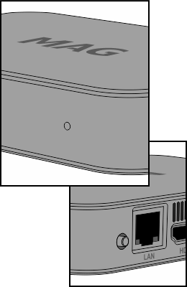
There are 3 modes:
- Mode 1. Switch to alternative NAND - Press and hold service button, power on STB. Wait until LED indicator change it's mode (LED is white, slow blinking). If button button will be released STB will load in mode 1. Not releasing of button - STB will go to mode 2.
- Mode 2. Reset to default settings - (White LED, fast blink). If button button will be released STB will load in mode 3. Continue to hold will result in - go to mode 3.
- Mode 3. “Emergency-mode” - STB Boot from USB/DHCP - (White LED, without blinking). If button button will be released STB will load in mode 3. Continue to hold will result in - Standard load.

"Emergency" mode
Activating of Mode 3 initiate loading of kernel from USB storage device. If there is no kernel on USB devices then STB initiates DHCP mode and firmware loading according to DHCP options. To load STB in “Emergency - USB” it is necessary to create directory mag351 or mag352 on USB storage device (FAT32) and copy kernel file Bootstrap (take from release) there.

