RC Code IRDA-4807 (not programmable)
Protocol RC5 38KHz Code page - 14 (0xE)
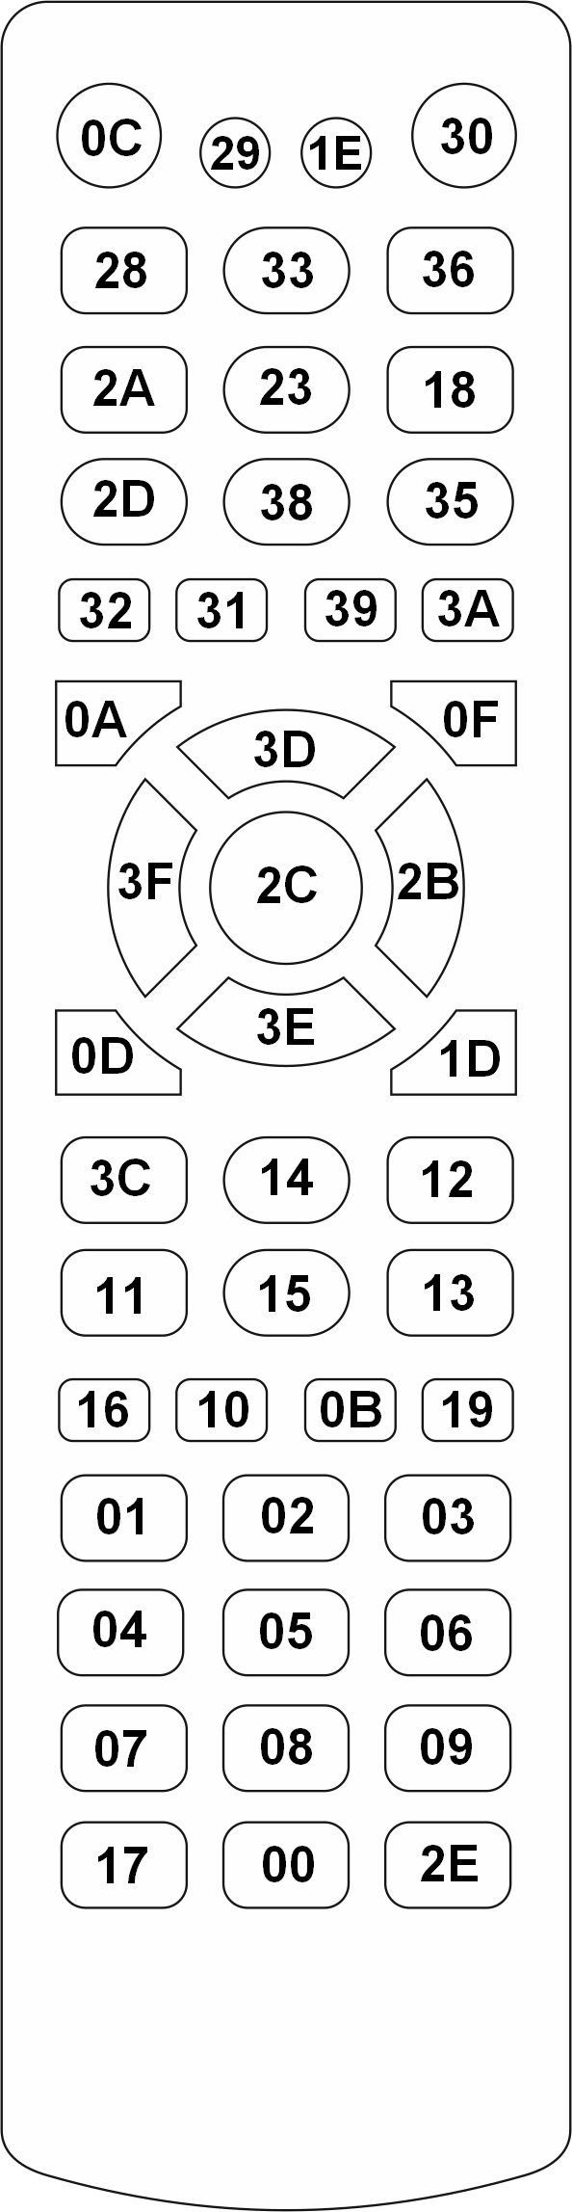

RC Code IRDA-4513 (programmable)


